SUBJECT* | Boiler Regulator Repair

GENERAL INFORMATION
CONTRACTING OFFICE’S ZIP CODE* | 80111
SOLICITATION NUMBER* | 36C25926Q0021
RESPONSE DATE/TIME/ZONE | 11-07-2025 14:00 MOUNTAIN TIME, DENVER, USA
ARCHIVE | 10 DAYS AFTER THE RESPONSE DATE
RECOVERY ACT FUNDS | N
SET-ASIDE | SBA
PRODUCT SERVICE CODE* | J045
NAICS CODE* | 238220
CONTRACTING OFFICE ADDRESS | Department of Veterans Affairs  Network Contracting Office  NCO 19  6162 South Willow Drive, Suite 300  Greenwood Village CO 80111
POINT OF CONTACT* | Contract Specialist  Natasha Holland  natasha.holland@va.gov  303.712.5753
PLACE OF PERFORMANCE
ADDRESS | Department of Veterans Affairs
 | Eastern Colorado Healthcare System
 | Rocky Mountain Regional VA Medical Center
 | 1700 N. Wheeling Street
 | Aurora CO
POSTAL CODE | USA
COUNTRY

ADDITIONAL INFORMATION
AGENCY’S URL
URL DESCRIPTION
AGENCY CONTACT’S EMAIL ADDRESS
EMAIL DESCRIPTION

DESCRIPTION
The purpose of this amendment 0001 to RFQ 36C25926Q0021 is to extend deadline for quote and questions, send out Site Visit Date and post initial vendor questions and answers.

The deadline for quotes is hereby extended to November 07, 2025 at 14:00 MT.
The date for the Site Visit will be October 30, 2025 @0900. The site visit will start the North Entrance, in front of the Inpatient North (K) entrance. If your company is planning to attend please confirm via email to natasha.holland@va.gov and thaddeus.gray@va.gov with the name and phone number before 29 October 2025 @1500 MT.
The deadline for all questions is extended due to site visit. Questions are due 13:00 MT Oct 31, 2025. They must be submitted by email to natasha.holland@va.gov and thaddeus.gray@va.gov. Participants must not ask questions of onsite VA employees. All questions answered outside of this requirement of this solicitation may disqualify a vendor from award. Any questions submitted after this deadline will not be answered.
Vendor Questions and Answers Amendment 0001
Q1. Are there pictures that can be provided of the boiler system and/or the valve needing
replacing?
Q2. Will there be a site visit for the existing gas pressure regulator valve trains serving the four
Cleaver-Brooks 4WI-200-700-200ST boilers? If not, will pictures be provided?
A2. The site visit is set for 30 October 2025 @0900. See above for exact information. Site visit shall be at no cost to the government. If planning to attend please confirm via email to natasha.holland@va.gov and thaddeus.gray@va.gov with the name and phone number before 29 October 2025 @1500 so that we have an accurate number of vendors.
Q3. Can photos of PRV tags be provided to make a proper quote for OEM part and installation cost?
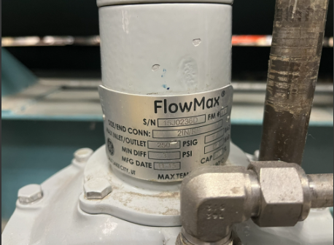
Q4. Does this contractor have to have specific Cleaver Brooks System Experience?
A4. The contractor should show experience with Cleave Brooks System.

